

RECITAL PROGRAM

Negra Sombra Xoan MONTES

Fantasía sobre a Negra Sombra Juan DURÁN

Mallorca Isaac ALBÉNIZ/
Tr. Pablo RODRÍGUEZ

Siete Canciones Populares Españolas Manuel de FALLA

- El Paño Moruno
- Seguidilla Murciana
- Asturiana
- Jota
- Nana
- Canción
- Polo

Homenatge a Lorca Joan A. ARMENGÓS

- Los Cuatro Muleros
- Zorongo
- Anda Jaleo

Balada Galaica Pedro ITURRALDE
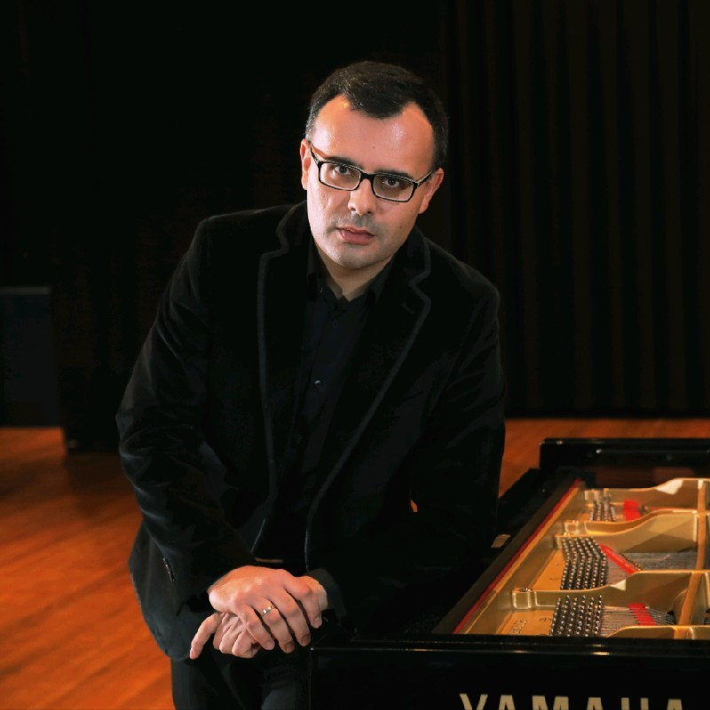

PhD. Pablo Rodríguez (Piano)
Conservatorio Superior de Música de Vigo

He studied piano and chamber music at the Conservatorio Superior de Música of Vigo with Enrique Goberna and Concepción Rodríguez, and at the Escola Superior de Música e Artes Escénicas of Porto (Portugal) with Luís Filipe Sá, where he obtained the End of Grade Award in 2008. He expanded these studies for two years at the University of Alcalá de Henares (Madrid, Spain) with the Spanish pianist Josep Colom, and with other piano pedagogues such as Almudena Cano, Eulalia Solé, Luiz de Moura, Peter Bithell and Boris Berman.

Beside this, he studied Industrial Engineering at the University of Vigo, and has the degree of Ph. D. in Literature by the same institution, and Master in Musical Research by the International University of Valencia (Spain). He develops an intense activity as accompanist specialized in the clarinet and saxophone repertoires.
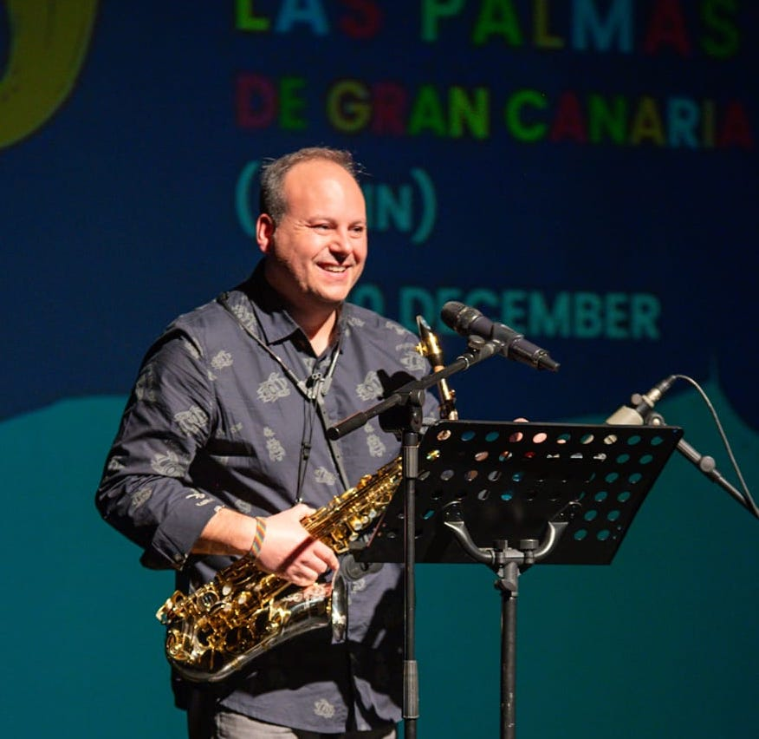

PhD. Antonio Fernández
Conservatorio Superior de Música de Vigo

Madrid, 1976. Saxophonist, teacher and researcher. Interested in a Practice as Research perspective, Antonio is an International Doctor in Education by the Universidad Autónoma de Madrid, under the direction of Doctor Enrique Muñoz and Doctor Álvaro Zaldívar, and with the auspices of Claude Delangle at CNSMDP, where he made his international research stage. His Doctoral Thesis Aportaciones al repertorio clásico del saxofón (1918-1950) desde la práctica con instrumentos de época was honored as Sobresaliente "Cum Laude”. He is also Profesor Superior de saxofón and Maestro, specialiced in Musical Education.

Involved in profesional wind orchestras, at 24 he won a tenure position at Banda Municipal de Santander. In that time, he was invited to collaborate with the most prestigious Spanish professional wind bands. For the 2025 season, he plays alto and soprano saxophones with the Banda Filharmónica de Vigo. Passionated for the chamber music, with the pianist Miguel Ángel Fernández Vega has recovered outstanding pieces for saxophone from the practice with historical saxophones and from the manuscripts. With the flutist Mar Bel forms Ferbelia Ensemble, playing music from 20th and 21st Centuries. He has played as a soloist or involving in professional ensembles across stages from Spain, Portugal, Italy and the Netherlands.

As a teacher, he had worked for several years at Junta de Castilla y León Conservatories. Since September 2022, he has been based in Galicia, his family homeland, teaching at Conservatorio Superior de Música de Vigo as saxophone and chamber music professor.

In the research field, he collaborates as a columnist in magazines and participates as a lecturer in music research seminars at universities, conservatoires and forums not only in Spain, but in Portugal, Italy, France and the Netherlands.

